Name: Weekly Math Homework – Q1:Wk4 Cohort: www.mrarchermath.weebly.com
Monday | Tuesday | Wednesday | Thursday
1) Tyree can build 1/6 of an engine in ¾ of an hour. At this rate how many engines could he build in 3 hours? | 5) Mr. Archer can swim 1 ½ laps in 2 ¾ minutes. At this rate how many laps can he swim in 8 minutes? | 9) John is traveling at a constant speed of 60 miles per hour. At this rate how long would it take him to travel 512 miles? | 13) A painter uses 5/12 of a gallon of paint to cover 3/5 of a wall. How many gallons of paint are need to cover the entire wall?
2) Steph scored 18 points in 4.5 minutes, her teammate Riley scored 11 points in 2.75 minutes. Who was more productive in terms of points scored per minute played? | 6) Walmart is selling 32 pieces of Halloween candy for $3.65. Target is selling 24 piece bags for $2.49. Who is selling Halloween candy for the cheapest and how much cheaper is it per piece of candy? | 10) George worked 9 hours over the weekend and made $110 raking leaves. Green Thumb Lawn Care pays its employees using the equation, pay = 12.50 x hours worked. George wants to know is it better to keep working on his own or take a job at Green Thumb? And why would make more money that way? | 14) A Black Bear can run 11.5 meters in 3.25 seconds. A Polar Bear takes 5 seconds to run 14 meters. Who can run faster in terms of meters per second?
3) Find the permeter:  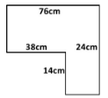 | 7) Find the permeter:  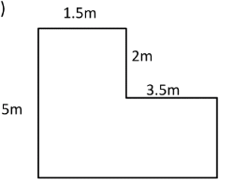 | 11) If the triangle below is increased by a scale of 2.5, What is the area of the englarged triangle?  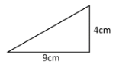 | 15) If the triangle below is increased by a scale of ½ , What is the area of the englarged triangle?  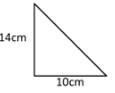
4) In Mr. Archer’s Math class there are 28 students. Their grades breakdown is as follows: 12 of them have an A, 8 have a B, 5 have a C, 2 have a D, and 1 is Failing. What is the probability that a random student is selected and has a A or B grade? | 8) On a fair number cube labeled 1-6, what is the probability of rolling a number less than 4? | 12) A bag contains 5 red marbles, 2 green marbles, 8 blue marbles, and 3 orange marbles. What is the probability of reaching into the bag and selecting a green or orange marble? | 16) Mr. El’s homeroom has 4 students in Orange house, 6 students in the Blue house, 8 students in the Purple house, 3 students in the Red house, 3 students in the Green and 2 students in the Yellow house. What is the probability that a student selected at random is in the orange house?

