Name: Weekly Math Homework – Q2:Wk3 Cohort: www.mrarchermath.weebly.com
Monday | Tuesday | Wednesday | Thursday
1.) Sonya can run 1 ½ miles in 2 hours. At this rate how long would she take to run a marathon, 26 miles? | 5.) Beth walked around her neighborhood. In ½ hour, she walked 1 ¾ miles. What was her rate in miles per hour? | 9.) Stephen ran a race that was 5 miles long. He ran ¼ of a mile in 1/8 of an hour. He ran the same pace the entire race, how many hours did it take him to finish the race? | 13.) A blueprint uses a scale of ¼ inches represents 12 feet. If living room wall is 2 ½ inches on the blueprint how many feet is it in reality?
2.) The temperature at 6:00 p.m. was 24 degrees. At midnight the temperature was 36 degrees lower than it was at 6:00 p.m. What was the temperature at midnight? | 6.) Kylie spent 2/5 of her money on clothes, 1/8 of her money on food, and the rest on bills. If she spent a total of $500 on clothes, food, and bills, how much was spent on bills? | 10.) Kenny entered a triathlon which is a 12-mile race broken into three sections. He swam 1/6 of the miles, ran another 1/6 of the miles, and biked the rest. How many miles did Kenny bike? | 14.) A mountain top is measured at 1,247 feet above sea-level, a oceanic trench deepest mark is located at -575 feet below sea-level. What is the distance between the top of the mountain and the bottom of the trench?
3.) A store has 3 options when purchasing grapes: 3 pounds for $3.69, 5 pounds for $6.15, or 8 pounds for $9.84. What is the cheapest combination in terms of cost per pound of grapes? | 7.) ESPN magazine charges $73.25 for a year’s (12 months) worth of magazine is bought individually. However, if they offer a $2.75 discount each month for a year’s subscription. How much money would a reader save using the monthly subscription for a year? | 11.) The Sanchez family went out to dinner and spent $62.88 on their meal. They left an 18% tip for the waitress. How much did the Sanchez family spend in all? | 15) What is the constant of proportionality?  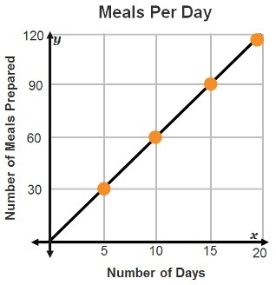
4.) The price of a company’s stock change rise and fall over a given quarter. If the price of Netflix stock started the month at $72 and dropped $12 the first week, increased $27 the second week, increased another $7 the third week, before finally dropping $17 in the final week of the month. What was the price of that stock at the end of the month? | 8.) A Penguin is swimming 10 feet below sea level, then swims up 5 feet before diving down another 15 feet, if he swims back up 8 feet, how far below sea-level is the Penguin. | 12.) Combine like terms  10n – 8b + 7n – 2n + n | 16.) NO CALCULATOR!  a) -9.83 x 8.6  b) -42.66 ÷ 7.9

