Name: Weekly Math Homework – Q2:Wk4
Cohort: www.mrarchermath.weebly.com
Monday | Tuesday | Wednesday | Thursday
1.) Tyson Engineering uses a scale of 2.5 centimeters represents 25 meters on a map. If a road measures 15 centimeters on the map, what is the length of the road in meters? | 5.) Betsy the race horse can run 1 ¼ miles in 1/12 of an hour. At this rate how long would it take the horse to run 5 miles? | 9.) The length of a parking lot is 50 feet and its width is 40 feet. If the parking lot is being increased by a scale of 2.5, what will the new area be? | 13.) Based on the graph below what is the constant of proportionality? (HINT: y/x)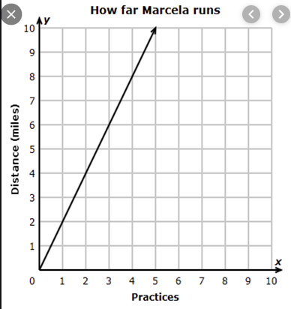
2.) NO CALCULATOR! The temperature at 4:00 am was -2 degrees below freezing. If the temperature dropped another seven degrees by 9:00 am, what was the temperature? | 6.) NO CALCULTOR!  Mason spent 2/5 of his money on basketball equipment, 1/8 of his money on books, and the rest on food this semester. If he spent a total of $500 on equipment, books, and food, how much was spent on food? | 10.) Kendrick entered a triathlon which is a 12-mile race broken into three sections. He swam 1/6 of the miles, ran another 1/3 of the miles, and biked the rest. How many miles did Kendrick bike? | 14.) NO CALCULATOR!  - -4.56 x 3.9  - -10.81 ÷ -2.3
3.) A restaurant is debating where to buy their tomatoes from. Direct Foods sells bundles of 25 tomatoes for $12.50. Eazy Farms sells bundles of 13 tomatoes for $6.75. Which company would be the better deal per tomato? | 7.) A library has 15,000 fiction books and 12,000 nonfiction books.  - $\frac{2}{5}$ of the fiction books were checked out.  - $\frac{3}{4}$ of the nonfiction books were checked out.  - Of the books checked out, $\frac{1}{3}$ were returned this week.  How many were returned this week? | 11.) Mr. Archer went to Starbucks and ordered a Latte for $3.98, a blueberry muffin for $2.50, and a yogurt parfait for $1.75. He was charged 7.5% sales tax. What was the total of his purchase? | 15.) What is the constant of proportionality for this table?  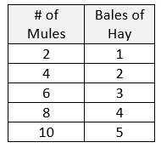
4.) The Cooper family spent $800 last month on bills. Of that amount 1/4 was used for electricity, 1/10 was spent on internet, 1/5 was spent on cable, the rest was used for food. How much did the Cooper family spend on food? | 8.) A jar contains 7 red marbles, 12 green marbles, 4 yellow, and 2 white marbles. What is the probability of reaching in the jar and taking out a yellow marble, NOT replacing it, and then taking out a white marble? | 12.) To win a game a player must roll a fair number cube labeled 1-6, and have it land on an even number. About how many times will they be expected to win if it is rolled 150 times? | 16.) NO CALCULATOR!  Connie earns $8.75 per hour and worked 15 hours. She gives $\frac{1}{5}$ of her earnings to her mom. How much money does she have left?

