Name: Weekly Math Homework – Q2:Wk7
Cohort: www.mrarchermath.weebly.com
Monday | Tuesday | Wednesday | Thursday
1) Jackie ran type 72 words per minute. At this rate how many words can she type in 3.25 minutes? | 5.) Mr. Archer can walk 1.5 miles in 0.75 of an hour. At this rate how long would it take him to walk 7.5 miles? | 9.) Samariyah can make 2 ½ necklaces in ¾ of an hour. If she made 8 necklaces, how long did it take her to complete them? | 13.) Find the constant of proportionality for Marcela.  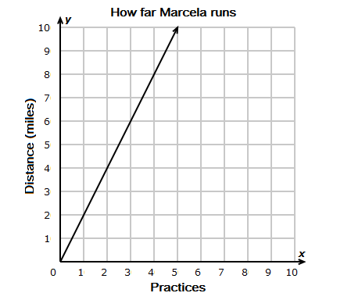
2.) Simplify.  $$-7\left(7k+1\right)-(6+3k)$$ | 6.) In 2018, the population of Matthews, NC, was p. It increased by 7%. Write two equivalent expressions that represent the population of Matthews now. | 10.) A pair of sneakers, s, was 30% off. Write two equivalent expressions that represent the sale price of the sneakers. | 14.) Simplify:  0.5(x – 2y) - (2.5x + 7y)
3.) Solve for z:  5z + 10 > -35 | 7) Solve for n:  15 – n = 22 | 11.) Solve for y:  12 = 1.5y - 15 | 15.) What is the constant of proportionality for this table?  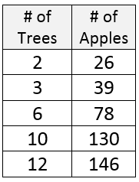
4.) Solve for x:  ½ x – 7 = -15 | 8.) A jar contains 7 red marbles, 12 green marbles, 4 yellow, and 2 white marbles. What is the probability of reaching in the jar and taking out a red marble? | 12.) A winter coat was on sale for 25% off and now costs $45.99. What was the price of the coat after the discount was applied? | 16.) A jar contains 7 red marbles, 12 green marbles, 4 yellow, and 2 white marbles. How likely is it that you will choose a marble that is NOT a green marble?

