TUESDAY
1. What is the sum of the degree measures of the complement and the supplement to a 16 degree angle?
2. Solve the following equation: $\frac{x+4}{6}$= 4
3. Robin had 40 apples to give to 3 groups of children
- The first group ate 1/8 of the total apples
- The second group ate 4 of the total apples
- The third group ate 20% of the total apples
How many apples were leftover?
4. How much greater is the circumference of the larger circle? (Image on SMART board)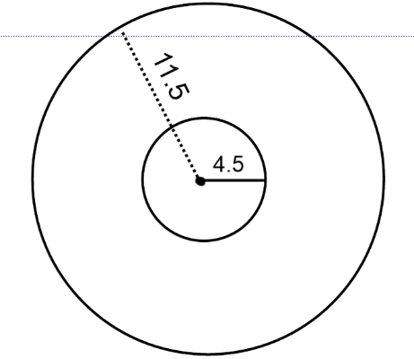

WEDNESDAY
1. What is the sum of the degree measures of the complement and the supplement to a 42 degree angle?
2. Solve the following equation: $\frac{2x+3}{2}$ = 12
3. Landon, Wes and Tim attempted 25 shots each.
- Landon made 36 out of 100 of his shots
- Wes made1/2 of his shots
- Time made 32% of his shots
Which statement is true?
A They all made the same number of shots
B Landon made more shots than Wes
C Time made more shots than Landon
D Wes made the most shots
4. Amy glued purple ribbon around the edge of her circular mirror. She used 63 inches of ribbon. What is the approximate diameter of the mirror?

THURSDAY
1. An angle measures 83 degrees. What is the sum of the degree measures of the complement and the supplement to the angle?
2. Solve the following: $\frac{-x+3}{5}$ = 10
3. A family went out to lunch and the meal cost $46.72
- The sales tax was 8% of the cost of the meal
- The tip was 15% of the meal and the tax
- There are 4 people in the family.
How much did the meal cost, per person?
A $14.00 B $14.50 C $14.95 D $15.25
4. The diameter of a circle is 6 cm. Determine the approximate area of the circle

FRIDAY
1. What is the sum of the complement and supplement to an angle that measures 31 degrees?
2. Solve the following: $\frac{2n+4}{4}$ = 5
3. Michael’s lawn measures 12 feet wide and 15 feet long. Sue’s lawn measures 36 feet wide and 50 feet long. How many times larger is Sue’s lawn than Michael’s lawn?
A 1/10 B 1/3 C 3 D 10
4. Determine the total area of the figure shown below
